**Designing a server architecture for an eCommerce platform like Shopee or Lazada using method clustering, load balancing, containerization or virtualization, whitelisting, and blacklisting involves creating a highly scalable, secure, and efficient infrastructure.**

**Architecture Design:**

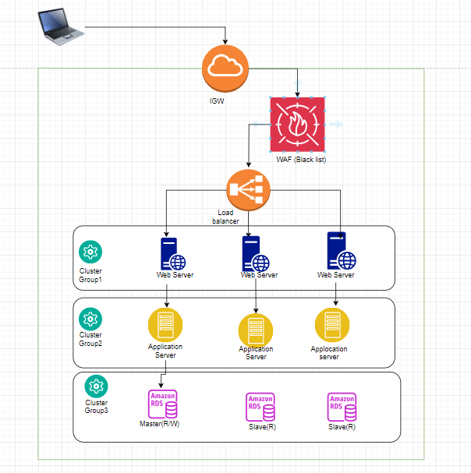

1. **Internet Gateway:**
   * Entry point for all external traffic.
2. **Load Balancer:**
   * Distributes incoming traffic across multiple application servers.
   * Ensures no single server is overwhelmed, improving performance and reliability.
3. **Application Servers Cluster:**
   * Multiple application servers running in containers or virtual machines.
   * Handles business logic and user requests.
   * Connected to the load balancer.
4. **Microservices:**
   * Decompose the application into microservices for better scalability and maintainability.
   * Each microservice (e.g., user service, product service, payment service) runs in its own container.
5. **Database Cluster:**
   * Separate clusters for read and write operations.
   * Ensures high availability and performance.
   * Includes master-slave replication for redundancy.
6. **Caching Layer:**
   * Cache frequently accessed data to reduce database load and improve response times.
   * Use tools like Redis or Memcached.
7. **Content Delivery Network (CDN):**
   * Distributes static content (e.g., images, videos) to users from the nearest edge location.
   * Reduces latency and improves load times.
8. **Security Layers:**
   * **Whitelisting:** Allows only trusted IPs to access certain services.
   * **Blacklisting:** Blocks known malicious IPs.

**Detailed Components and Steps:**

**1. Load Balancing:**

* **Component:** Load Balancer (e.g., AWS ELB, Nginx, HAProxy).
* **Function:** Distribute traffic to multiple application servers.

**2. Application Servers:**

* **Component:** Containers (e.g., Docker) or Virtual Machines (e.g., VMware, KVM).
* **Function:** Run application code.
* **Cluster Management:** Use Kubernetes or Docker Swarm for orchestration.

**3. Microservices Architecture:**

* **Component:** Microservices.
* **Function:** Each service (e.g., user management, catalog, orders, payment) runs independently.
* **Deployment:** Each microservice is deployed in its own container or VM.

**4. Database Clustering:**

* **Component:** Databases (e.g., MySQL, PostgreSQL).
* **Function:** Handle data storage.
* **Clustering:** Use master-slave replication, sharding for scalability.

**5. Caching:**

* **Component:** Cache (e.g., Redis, Memcached).
* **Function:** Store frequently accessed data to reduce database load.

**6. CDN:**

* **Component:** Content Delivery Network (e.g., Cloudflare, AWS CloudFront).
* **Function:** Serve static content from edge locations.

**7. Security:**

* **Component:** Firewalls, ACLs.
* **Function:** Implement whitelisting and blacklisting.

**Implementation Steps:**

1. **Deploy the CDN/WAF:**
   * Configure to serve static assets and protect against web threats.
2. **Set Up the Load Balancer:**
   * Configure it to distribute traffic across application servers.
3. **Deploy Application Servers:**
   * Use containers or VMs.
   * Orchestrate with Kubernetes or Docker Swarm.
4. **Microservices Deployment:**
   * Break down the monolithic application into microservices.
   * Deploy each service independently.
5. **Database Clustering:**
   * Set up read/write clusters.
   * Configure replication and sharding.
6. **Implement Caching:**
   * Deploy a caching layer with Redis or Memcached.
7. **Configure Security:**
   * Set up whitelisting and blacklisting on firewalls and ACLs.

By combining these methods, the architecture will support high traffic volumes, ensure data integrity and security, and provide a scalable and maintainable infrastructure for an eCommerce platform.